**About the final project and assessment: Modeling data in Power BI**

**The purpose of the assessment**

In this project assessment, you will have the opportunity to apply your knowledge in an end-to-end scenario where you have the opportunity to build and optimize a data model. In this assessment, you'll work with advanced data models, make use of DAX and optimize a model for performance in Power BI. This project assessment will allow you to test yourself on the various skills you learned in this course, as outlined above.

You will then conclude this course with a graded final quiz. The primary purpose of the quiz is to check your knowledge and understanding of the key learning objectives of the course.

Most importantly, it will help you establish which topics you have mastered and which require further study before completing the course. Ultimately, the graded assessment and quiz are designed to help you make sure that you can apply what you have learned.

**What to expect from the graded quiz**

The quiz tests only the topics covered throughout the course, so there shouldn’t be any surprises. It will take about 1 hour and 30 minutes to complete, and you need to score 80% to pass. You can take the quiz more than once if you don’t achieve this score, but note that the questions will vary each time. Review the feedback on your answers. Where necessary, go back and work through the topics that you feel require your further attention.

**How to prepare for the final assessment**

This assessment will test you on the topics covered throughout this course, which include the following:

* The fundamentals of data models.
* Using advanced data analytics expressions (DAX) in Power BI.
* Utilizing time intelligence calculations in DAX.
* Optimizing a model for performance in Power BI.

**Conclusion**

To ensure that you are well-prepared, it is advisable to review the previous quizzes you completed during this course, with a particular focus on any questions that were answered incorrectly. Take note of the feedback that is provided and use it as guidance for the topics that require greater attention. Revisit any videos, readings, and exercises from this course as needed to improve your mastery of the content.

Good luck!

**Exercise: Building and optimizing a data model**

**Introduction**

You should now understand the fundamentals of data modeling in Power BI. In this exercise, you’ll apply your knowledge of these concepts by building and optimizing a data model in Power BI.

By completing this exercise, you’ll demonstrate your ability to:

* Work with advanced data models.
* Make use of DAX in Power BI.
* And optimize a model for performance in Power BI.

**Scenario**

Adventure Works’ sales are stagnating, and a growing inventory issue contributes to the problem. You're provided with sales figures, manufacturing data, and inventory levels. You need to turn this information into actionable insights so Adventure Works can solve its issues.

By building and optimizing an efficient data model, you can revolutionize how Adventure Works operates and help to align its products, markets, and strategies for success.

**Instructions**

Download and open the Adventure Works Power BI report titled *AdventureWorksSales.pbix* and follow the prompts below to complete the exercise.

[AdventureWorksSales](https://d3c33hcgiwev3.cloudfront.net/ZIEStzUdQc2ZGVo20t1czw_225878d4fe874f15a3888ac1a0e7e2e1_AdventureWorksSales.pbix?Expires=1711238400&Signature=a~0YvVq5qjkBddA1AG5kxoDN2atXd717N7-mWRHOumETax53DyNnNvtaKVPTFDVnxbeSjSyiR36~ZbAVgTiS8LKqEQ5UqkxtMoxf5AlUVIfri-2JD~b2jDv~oD4RjdoLEzbPLyBx77gv0wM2SLaTMbKNKJj-62NxBxtisKAk3n4_&Key-Pair-Id=APKAJLTNE6QMUY6HBC5A" \t "_blank)

[PBIX File](https://d3c33hcgiwev3.cloudfront.net/ZIEStzUdQc2ZGVo20t1czw_225878d4fe874f15a3888ac1a0e7e2e1_AdventureWorksSales.pbix?Expires=1711238400&Signature=a~0YvVq5qjkBddA1AG5kxoDN2atXd717N7-mWRHOumETax53DyNnNvtaKVPTFDVnxbeSjSyiR36~ZbAVgTiS8LKqEQ5UqkxtMoxf5AlUVIfri-2JD~b2jDv~oD4RjdoLEzbPLyBx77gv0wM2SLaTMbKNKJj-62NxBxtisKAk3n4_&Key-Pair-Id=APKAJLTNE6QMUY6HBC5A" \t "_blank)

**Step 1: Download and import the data model.**

1. Download and save the Excel workbook **AdventureWorksSales.pbix**. The data model contains two datasets: **Customers** and **Orders**.
2. Load the data from the Excel sheet into Power BI. Ensure you load all tables in the workbook.
3. Access the model for editing by selecting **Data view**.

**Tip:** You can import data using the **Get Data** drop-down menu.

**Step 2: Optimize data types.**

Your next step is to optimize the data types for the **Customers** and **Orders** tables so that the data model functions efficiently and accurately.

**Optimizing Data Types for the Customers table**

1. Select the **Customers** table from the fields pane.
2. Access the **Column tools** tab on the top toolbar and navigate to the **Data type** option.
3. Assign data types to each column as follows:

* **Name** = **Text**
* **Surname** = **Text**
* **Location** = **Text**
* **Date of Birth** = **Date**
* **Phone Number** = **Text**
* **Membership Tier** = **Text**
* **Customer Source** = **Text**

**Optimizing Data Types for the Orders table**

1. Now that you have optimized the data types for the **Customers** table, you need to do the same for the **Orders** table. Select the **Orders** table from the **Fields** pane.
2. Take a moment to observe the first 10 records. Note which record has the highest **Order Quantity** value. Next, note which payment method was most used.
3. Access the **Column tools** tab on the top toolbar and navigate to the **Data type** option.
4. Assign data types to each column as follows:

* **Order Total** = **Decimal number**
* **Order ID** = **Whole Number**
* **Customer ID** = **Whole Number**
* **Product ID** = **Whole Number**
* **Order Date** = **Date**
* **Order Status** = **Text**
* **Order Quantity** = **Whole Number**
* **Payment Method** = **Text**
* **Billing Address** = **Text**
* **Discounts** = **Decimal Number**
* **Shipping Fee** = **Decimal Number**
* **Tracking Number** = **Text**

**Tip:** You can assign a data type by accessing the **Column Tools** tab on the toolbar and selecting the **Data Type** option.

**Step 4: Build and configure the model relationship.**

1. Access **Model** view to view the tables in your data model.
2. Connect the **Customers** and **Orders** table using the **Customer ID** fields.
3. Define the relationship between these two tables as **One-to-many**.
4. Change the cardinality selection from its current state to **One-to-many**.
5. Establish a **Single** cross filter direction.
6. Save the changes made to the data model.

**Tip:** You can define a relationship by double-clicking the connecting line.

**Step 5: Disable Auto date/time.**

1. Your final task is to disable the **Auto date/time** feature so you can manually maximize your model’s performance. Access and disable the **Auto Date/Time** feature.
2. Apply your changes.

**Tip:** You can access the Auto Date/Time feature from the **Options** menu’s **Data load** option.

**Conclusion**

By following these steps, you have demonstrated your ability to work with advanced data models, use DAX in Power BI, and optimize a model for performance in Power BI.

In addition, by building and optimizing an efficient data model, you’ve revolutionized how Adventure Works operates and helped the company to align its products, markets, and strategies for success.

**Exemplar: Building and optimizing a data model**

**Overview**

In the exercise *Building and optimizing a data model*, you were asked to put into practice what you have learned about building and optimizing data models in Microsoft Power BI.

Your task in this exercise was to build and optimize a data model for Adventure Works to help the company align its business for success. More specifically, you were asked to:

* Optimize the data types in the **Customers** and **Orders** tables to ensure efficiency and precision in data processing and calculations.
* Identify potential relationships between datasets and highlight the relationship between **Customer ID** columns in the **Customers** and **Orders** tables.
* Construct a one-to-many relationship between these tables, interpreting the connection that one customer can have multiple orders.
* To further streamline your data model's performance, you were required to deactivate Power BI’s **Auto Date/Time** feature, giving you more control over date fields.

This reading provides you with a step-by-step guide for completing these tasks. It also includes screenshots that you can compare against your own work.

You can review the techniques for this exercise in this course’s video items.

**Step 1: Download and import the data model.**

1. Download the workbook from the exercise page on the Coursera platform. Open the workbook on the Microsoft Power BI platform.
2. Select the **Data View** icon on the left vertical toolbar to switch your workspace to the **Data View**, where tables and their corresponding fields are displayed.

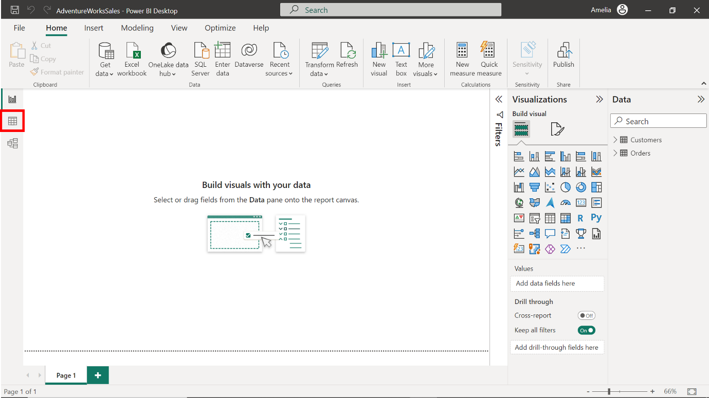

**Step 2: Optimizing data types.**

**Optimizing Data Types for Customers Table**

1. Select the column labeled **Customer ID**.

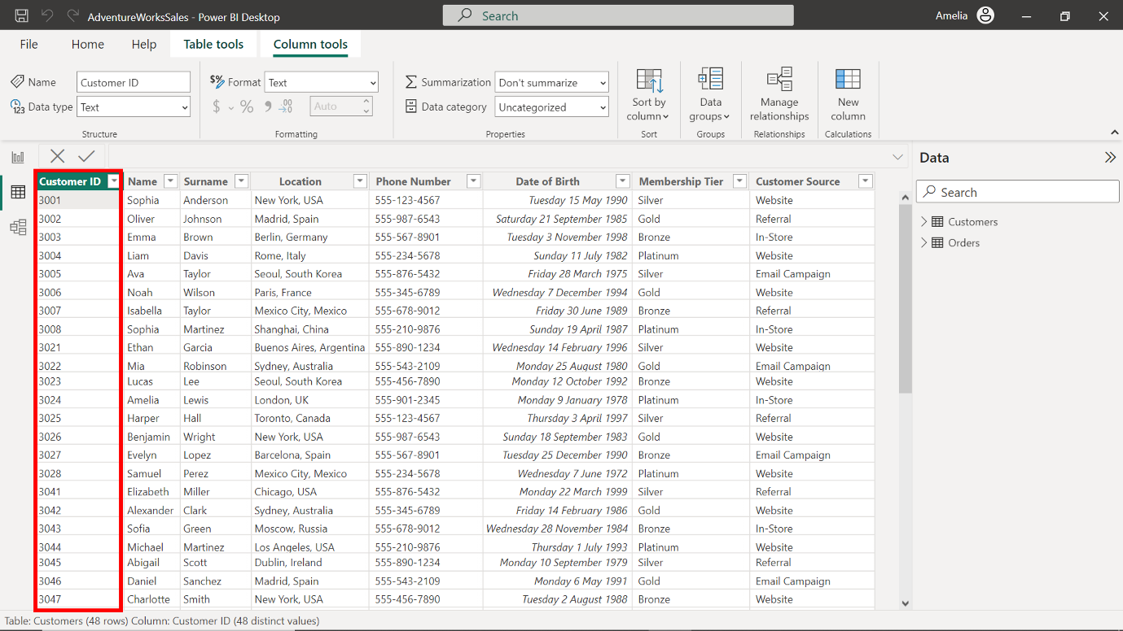

1. Access the **Column tools** tab on the top toolbar. Select the option labeled **Data type**.

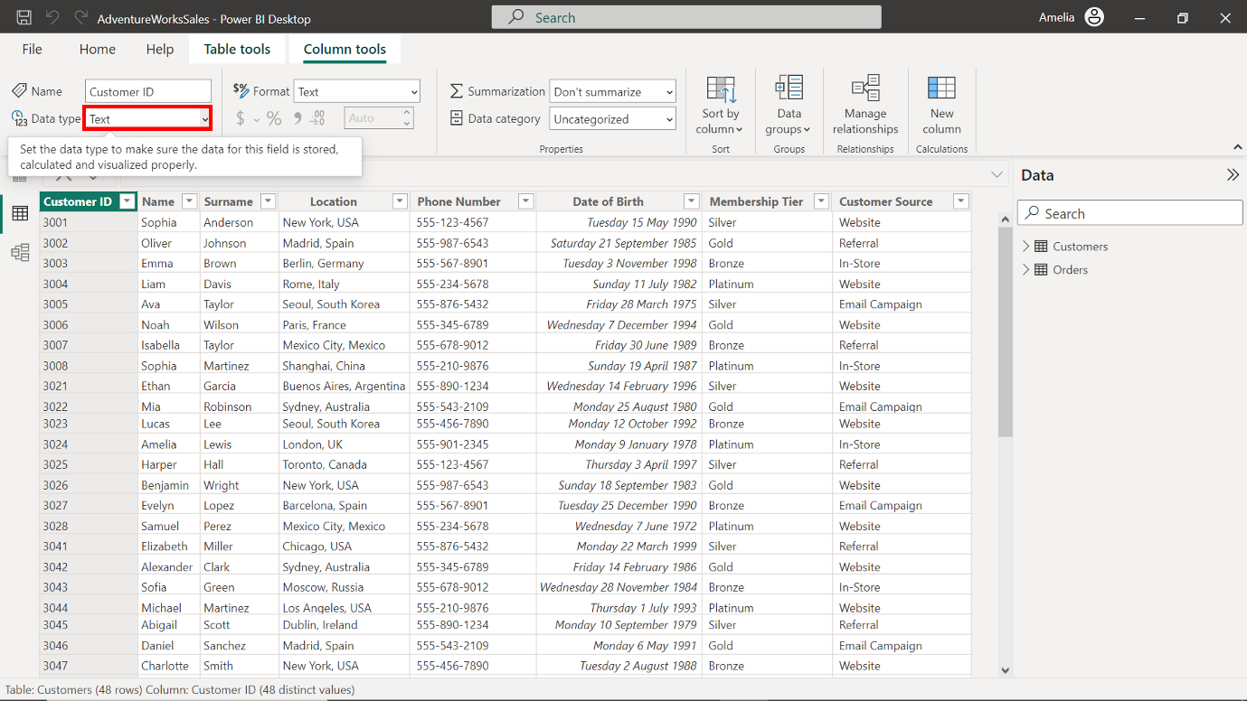

1. Upon selecting the **Data type** option, a dropdown will appear. For unique identifiers that are numbers, **Whole Number** is often the best fit.

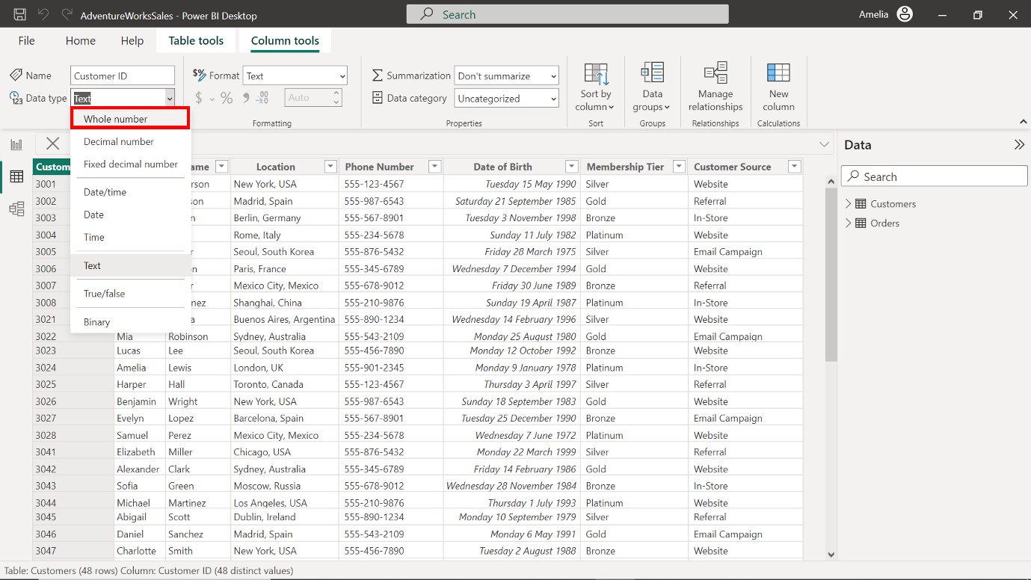

1. Select **Whole Number** to assign it to the **Customer ID** column. Accurately classifying the **Customer ID** as a **whole number** safeguards against potential data mismatches or misinterpretations during future analysis.

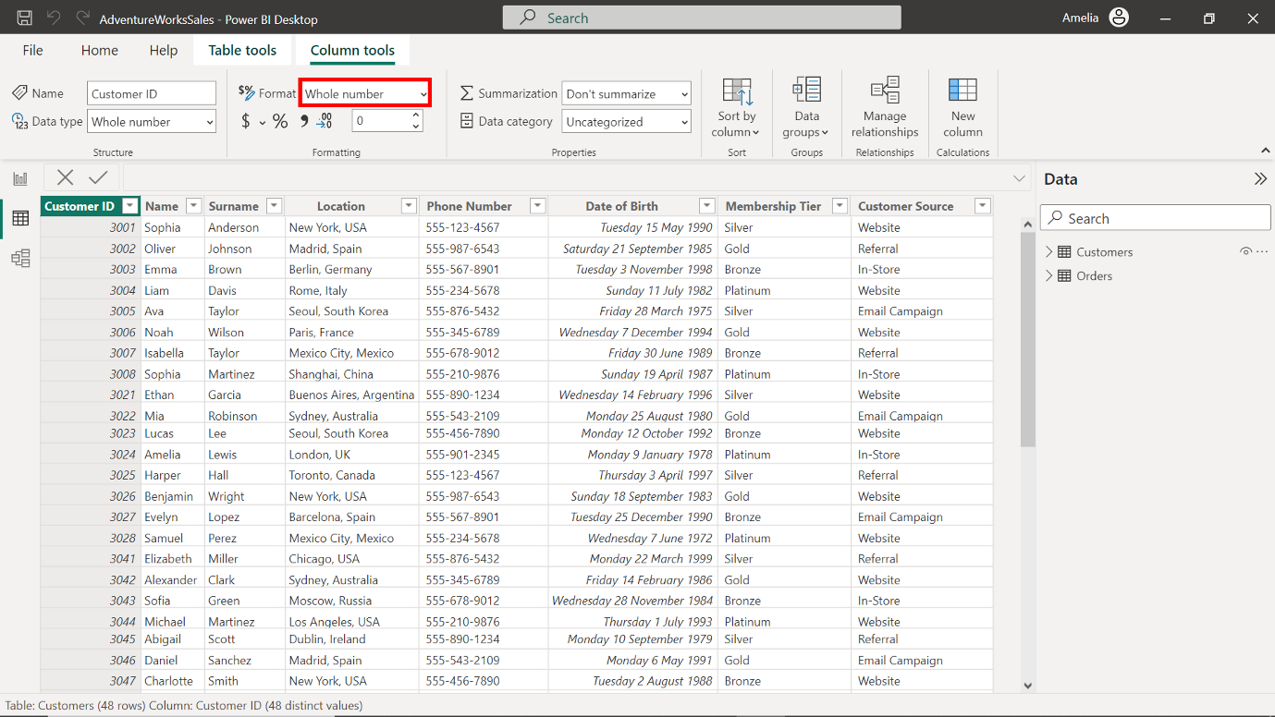

1. The Adventure Works **Customers** dataset contains multiple columns, and each must be optimized to ensure accurate reporting. To complete the optimization of the data types, repeat steps 1 - 4 for the remaining columns as follows:

* Change the data type of the **Name** column to **Text.**

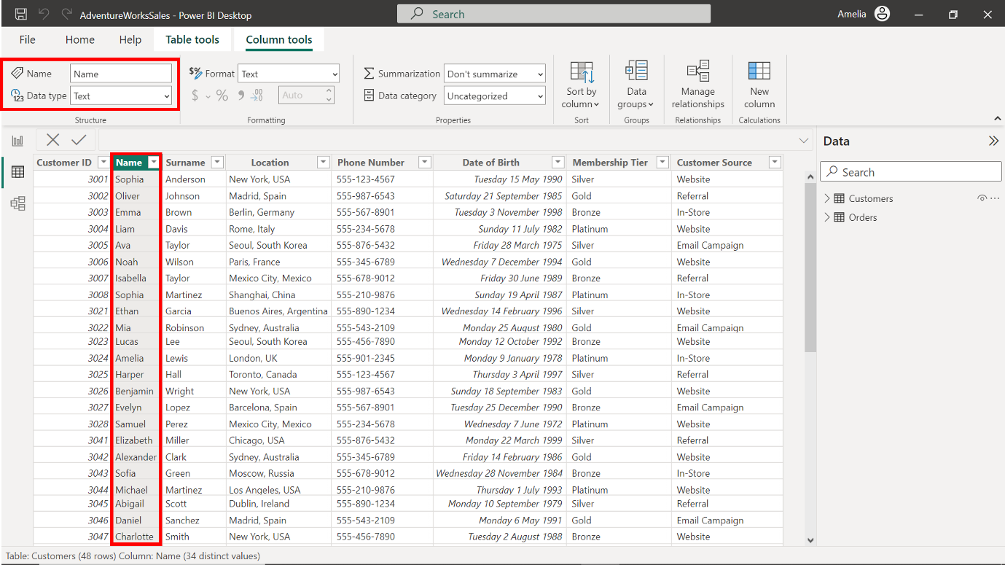

* Change the data type of the **Surname** column to **Text.**

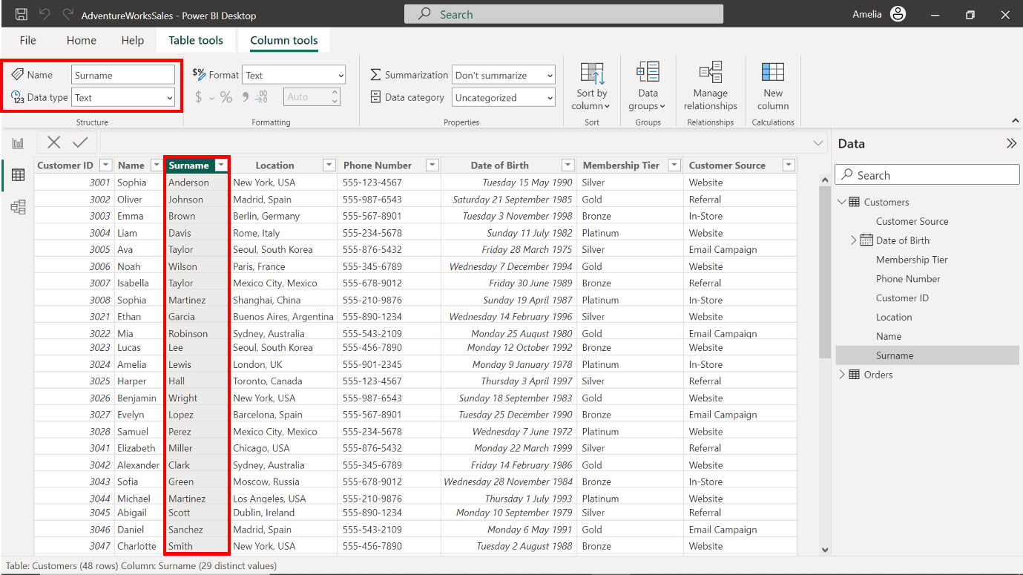

* Change the data type of the **Location** column to **Text**

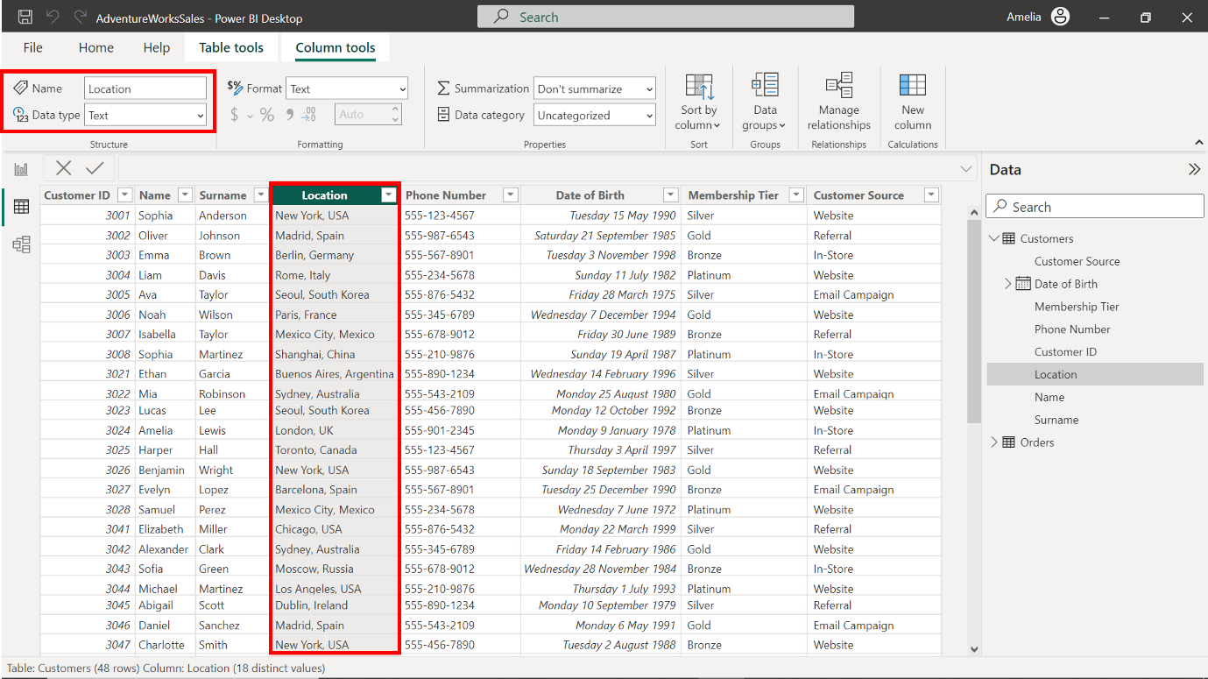

* Change the data type of the **Phone number** column to **Text.**

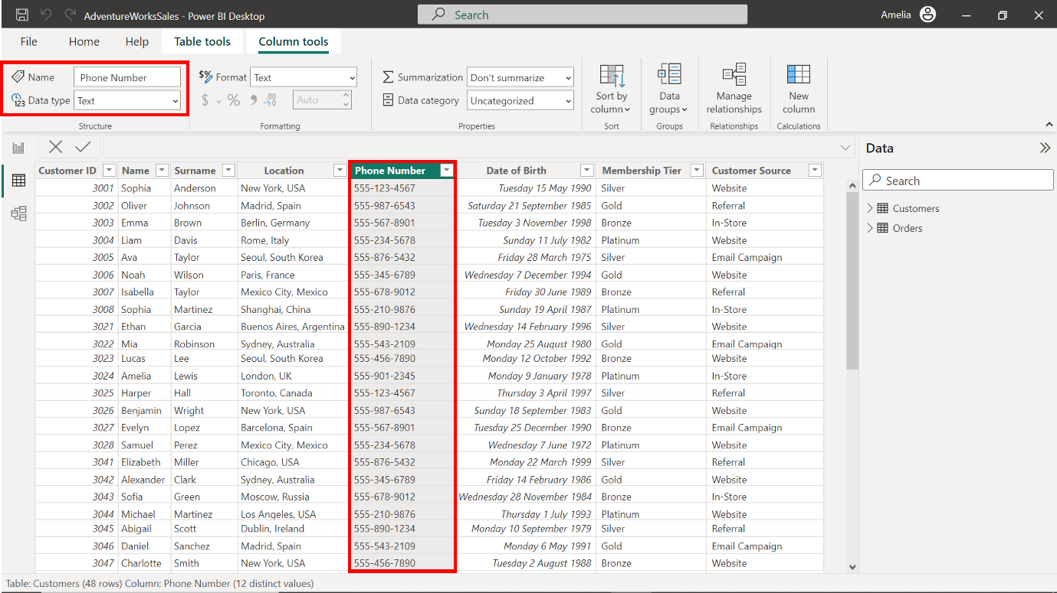

* Change the data type of the **Date of Birth** column to **Date.**

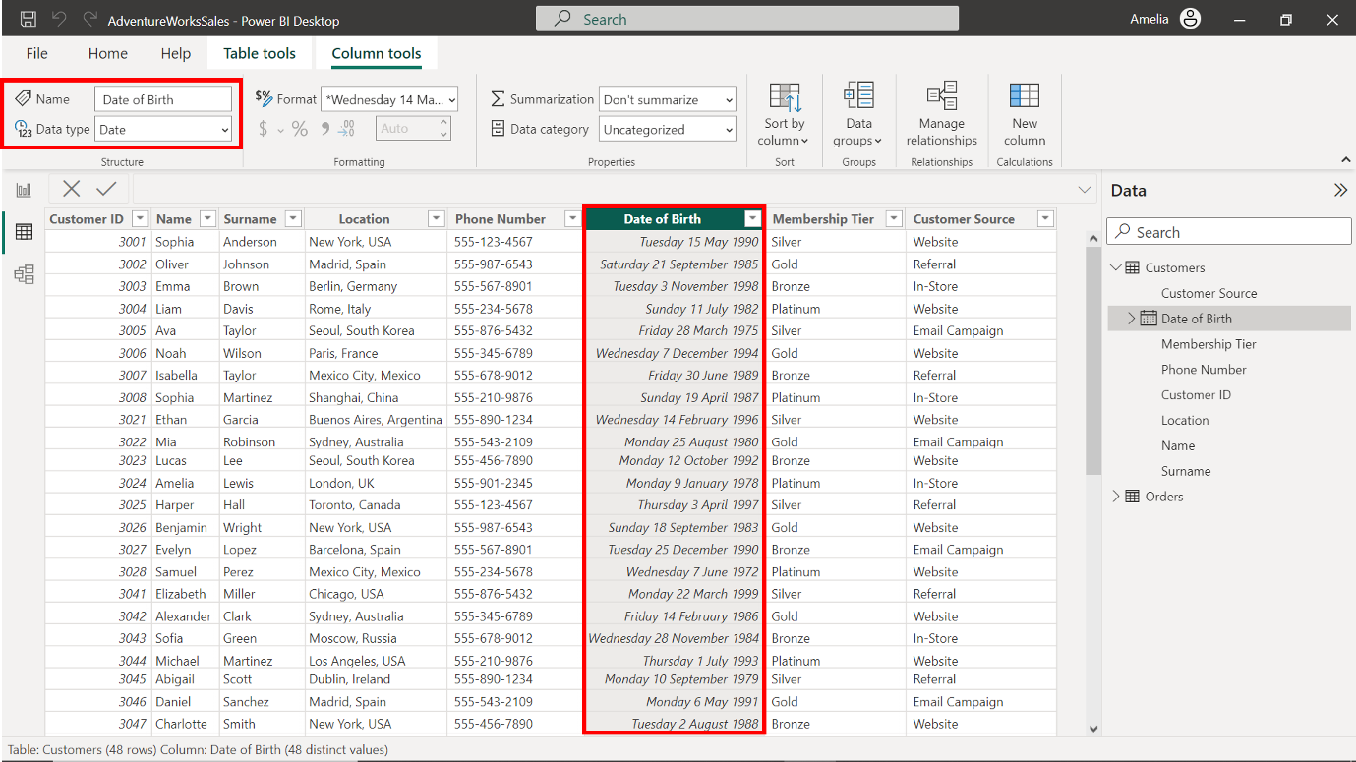

* Change the data type of the **Membership Tier** column to **Text.**

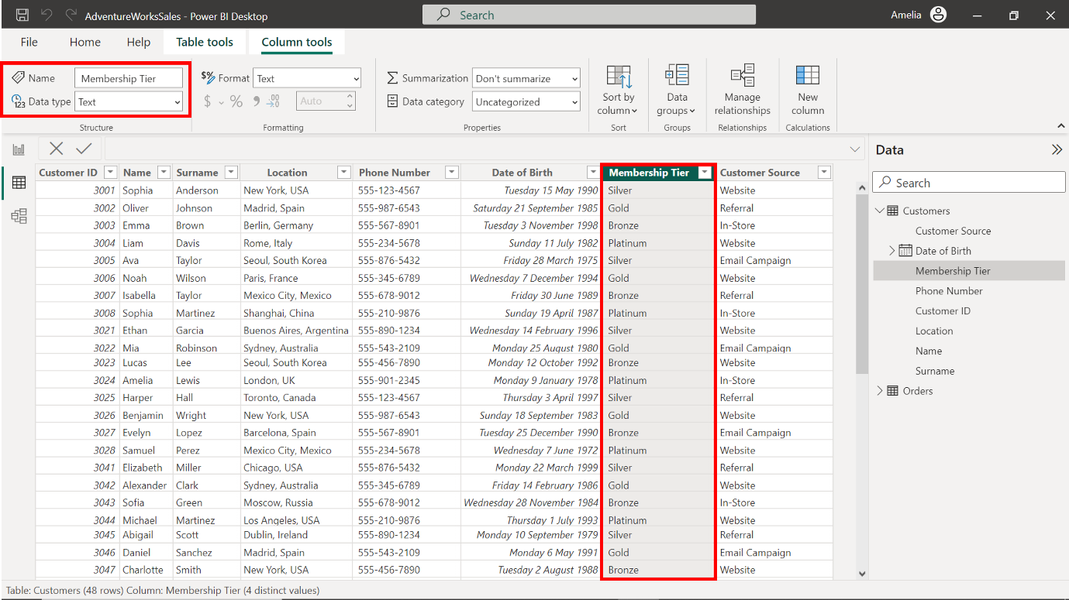

* Change the data type of the **Customer Source** column to **Text.**

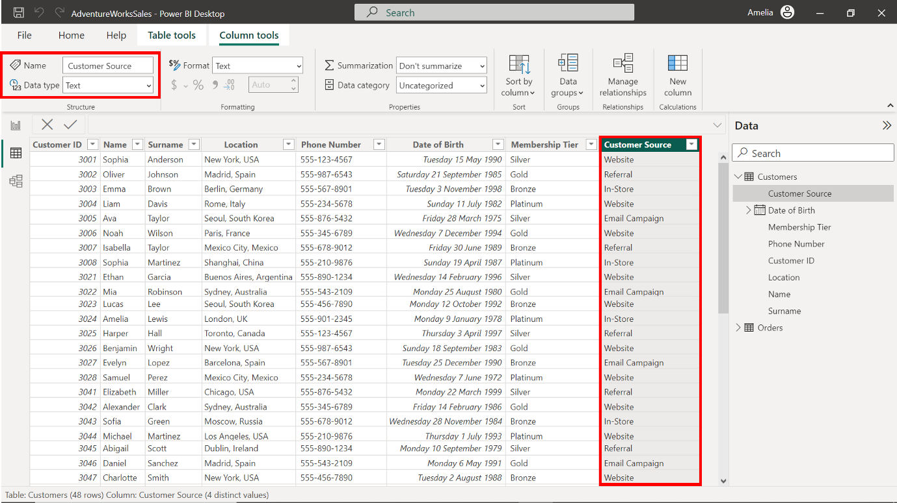

**Optimizing Data Types for the Orders table**

1. Select the **Orders** table from the **Fields** pane to bring its columns into focus.

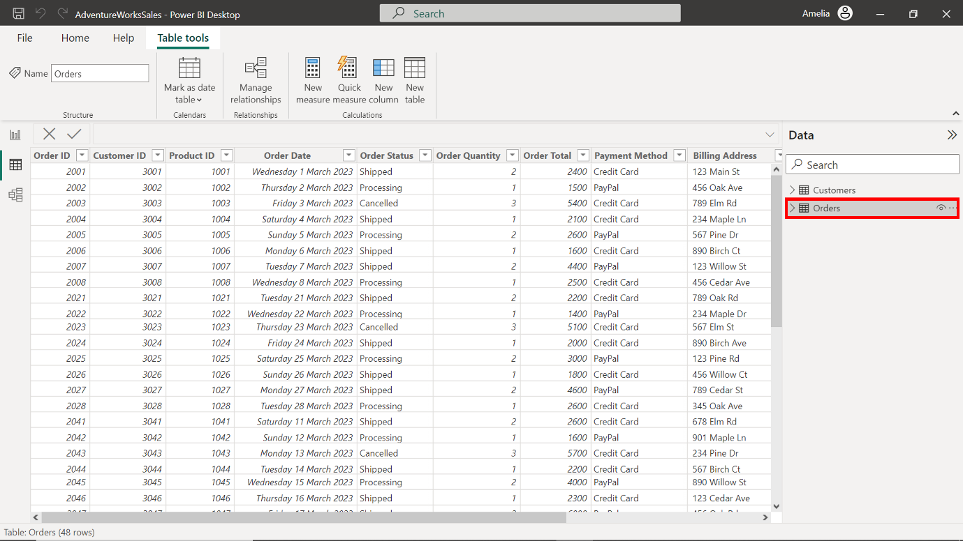

1. Observe the first ten records. The **Credit Card** payment method was selected six times, notably more frequently than other payment methods. **Product ID 1003** was ordered three times. Its repeated appearance suggests a high demand for this product.

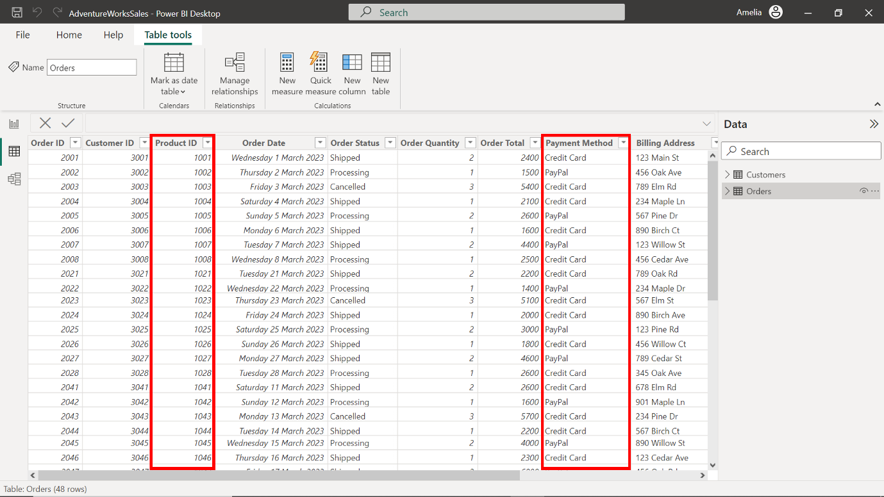

1. Access the **Column tools** tab on the top toolbar. Select the option labeled **Data type**.

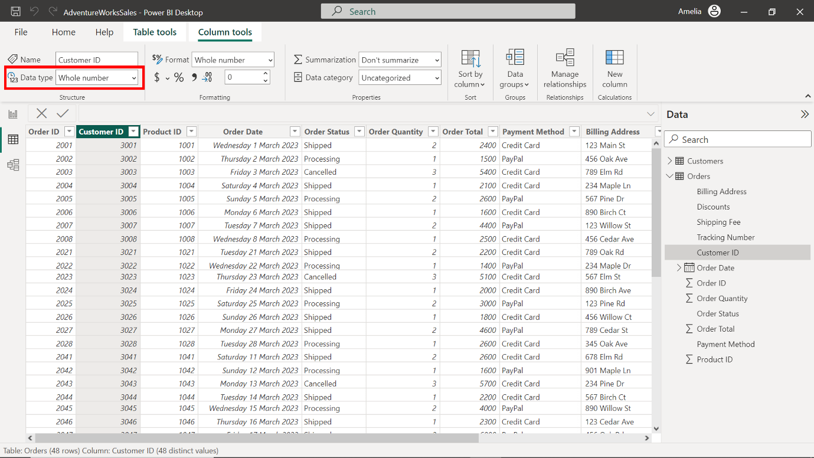

1. Each column in Adventure Works' **Orders** table holds significant business value. To complete the optimization of the table, assign the following data types to the columns:

* Change the data type of the **Order Total** column to **Decimal number**.

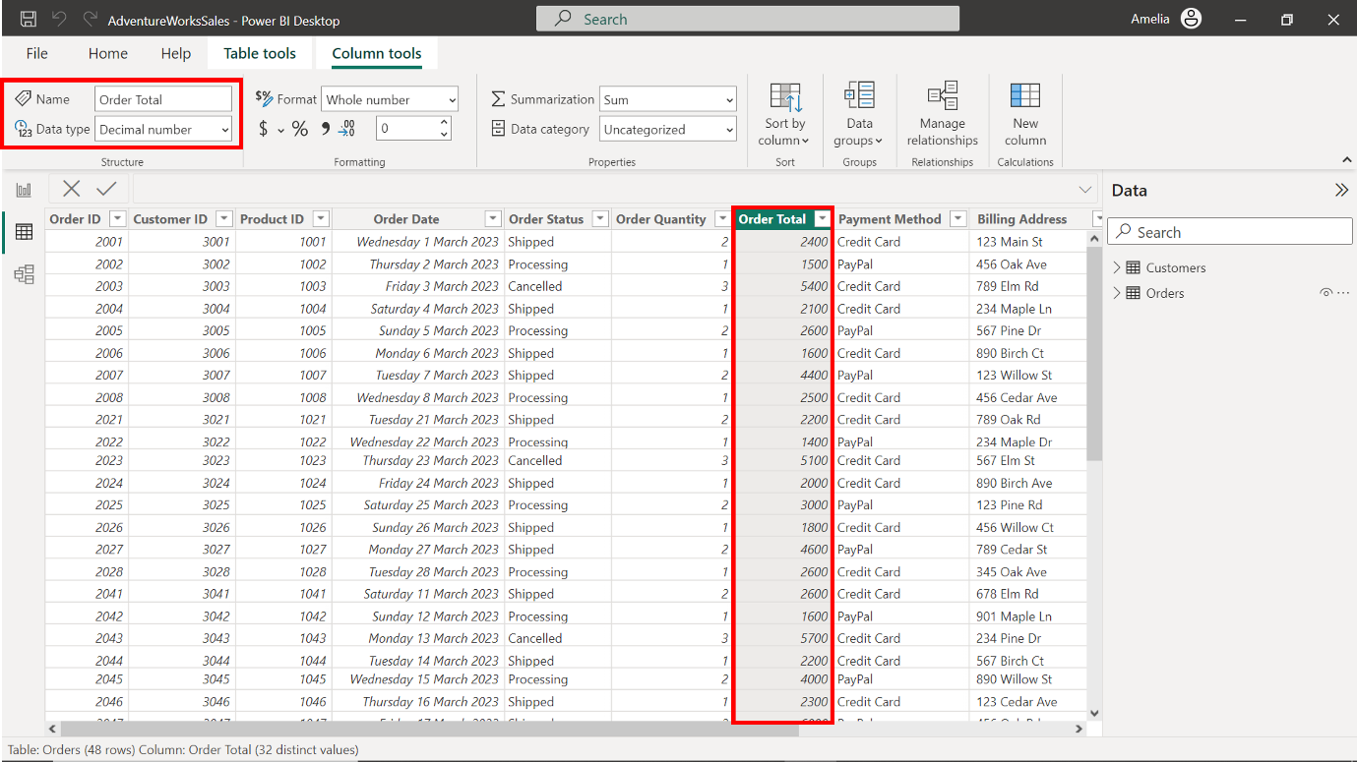

* Change the data type of the **Order ID** column to **Whole number**.

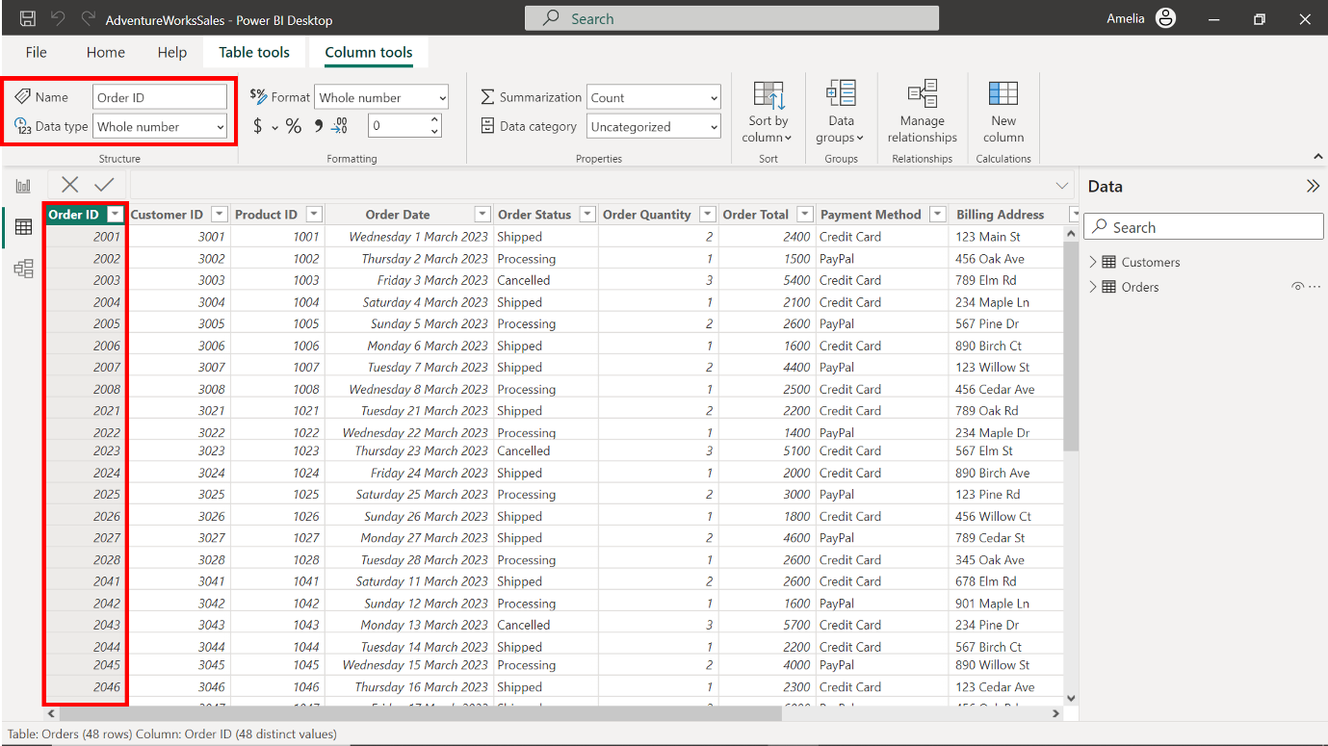

* Change the data type of the **Customer ID** column to **Whole number**.

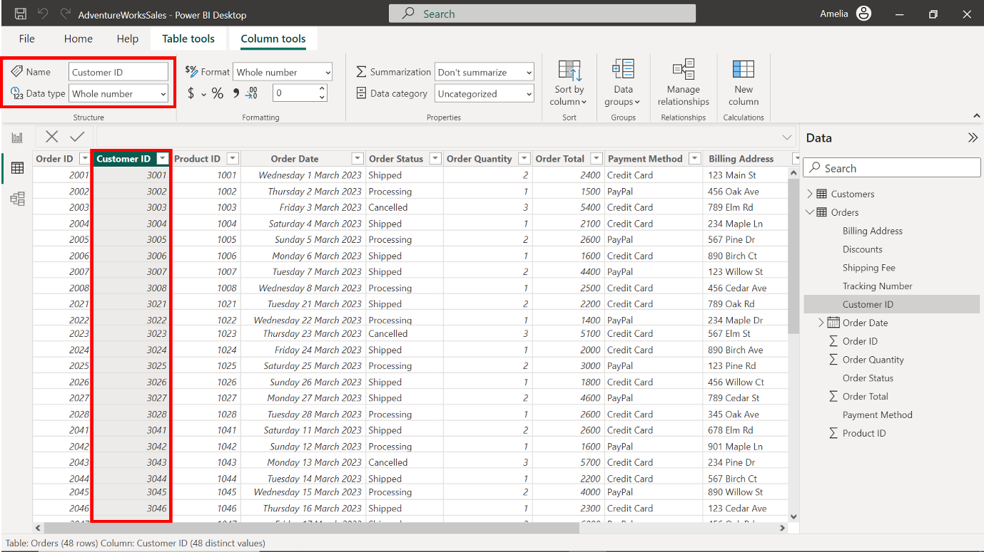

* Change the data type of the **Product ID** column to **Whole Number**.

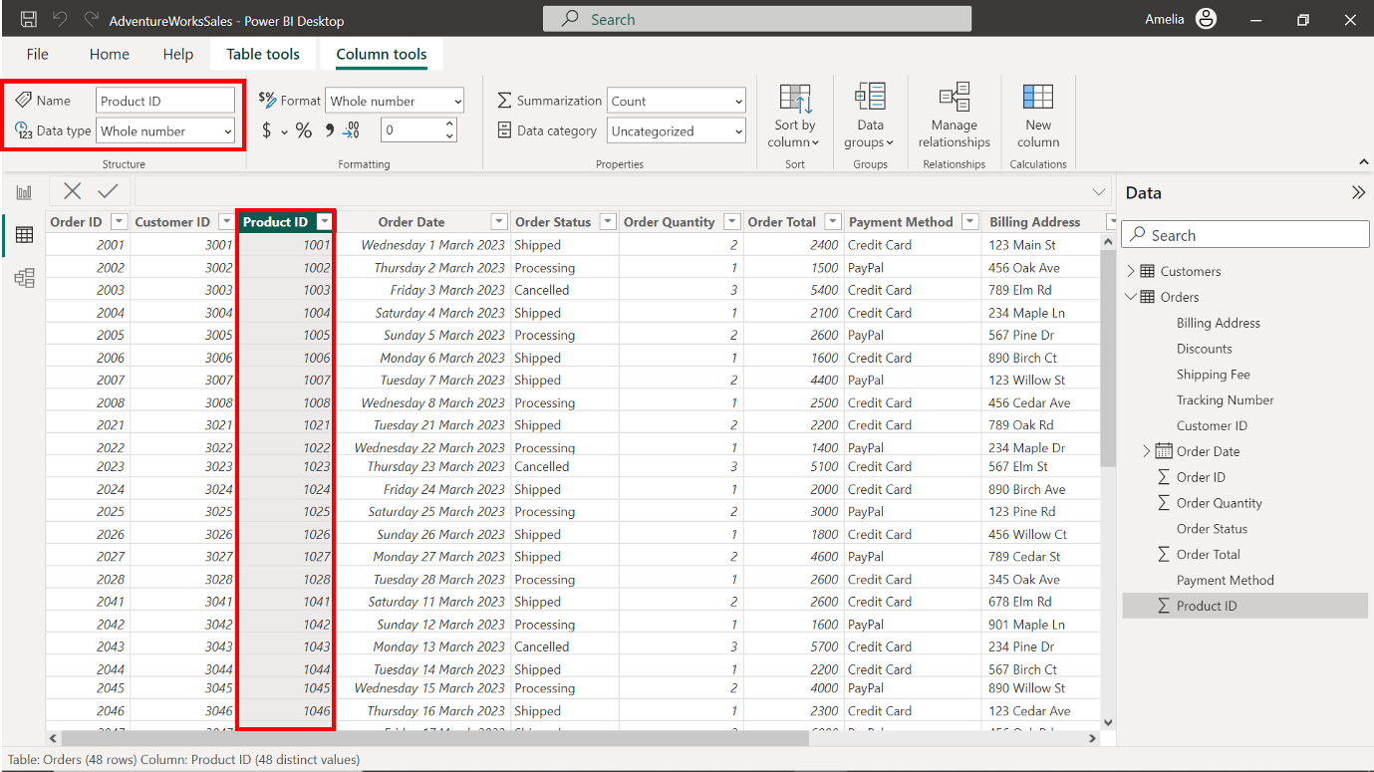

* Change the data type of the **Order Date** column to **Date**.

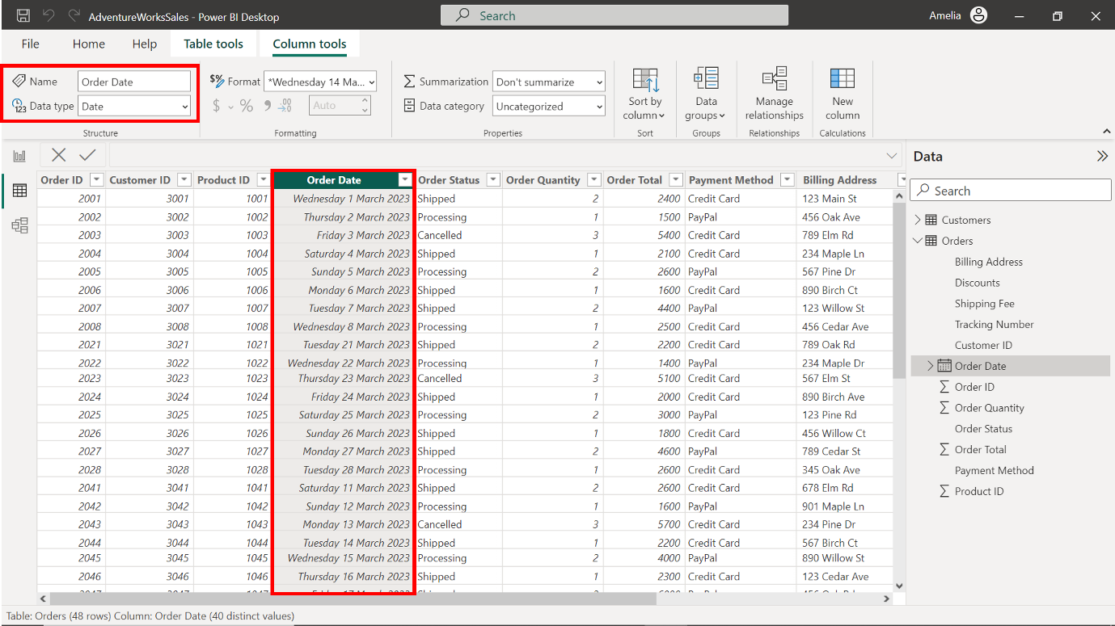

* Change the data type of the **Order Status** column to **Text**.

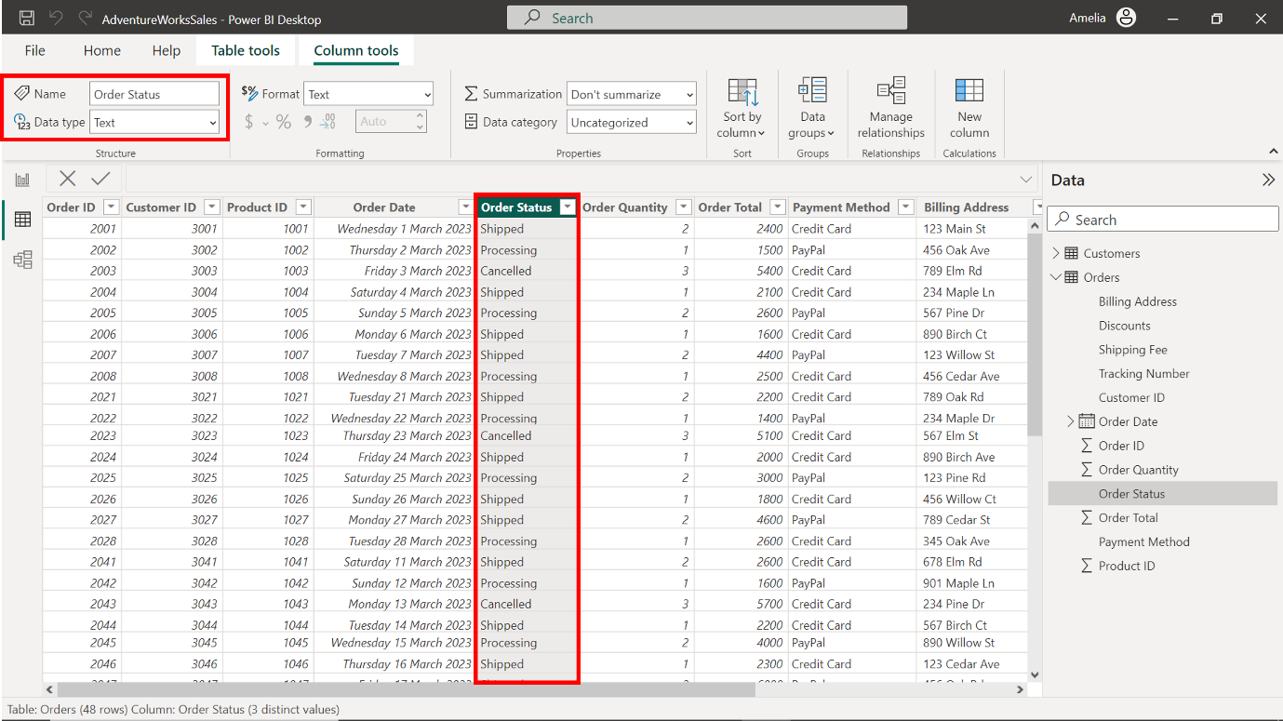

* Change the data type of the **Order Quantity** column to **Whole Number**.

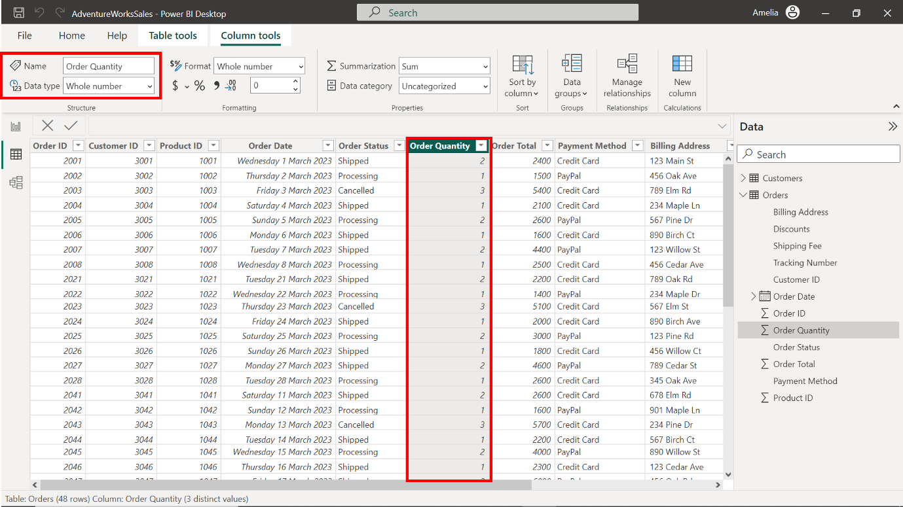

* Change the data type of the **Payment Method** column to **Text**.

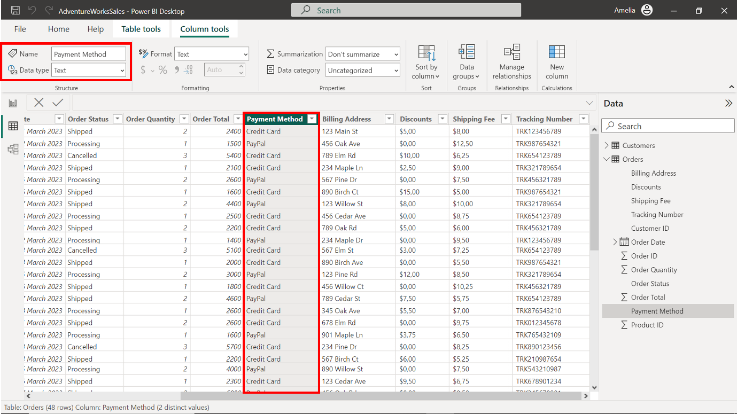

* Change the data type of the **Billing Address** column to **Text.**

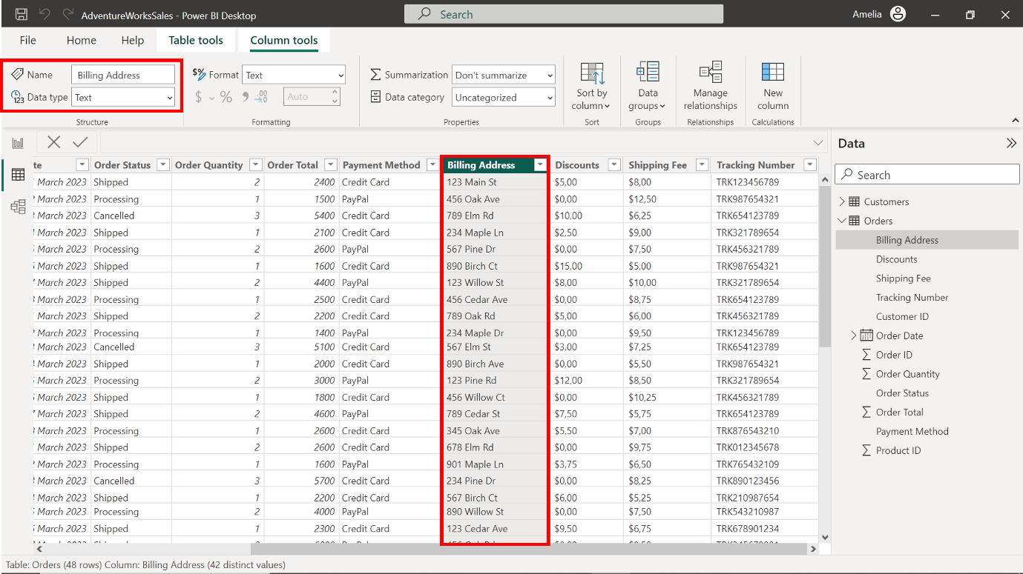

Change the data type of the **Discounts** column to **Decimal Number**.

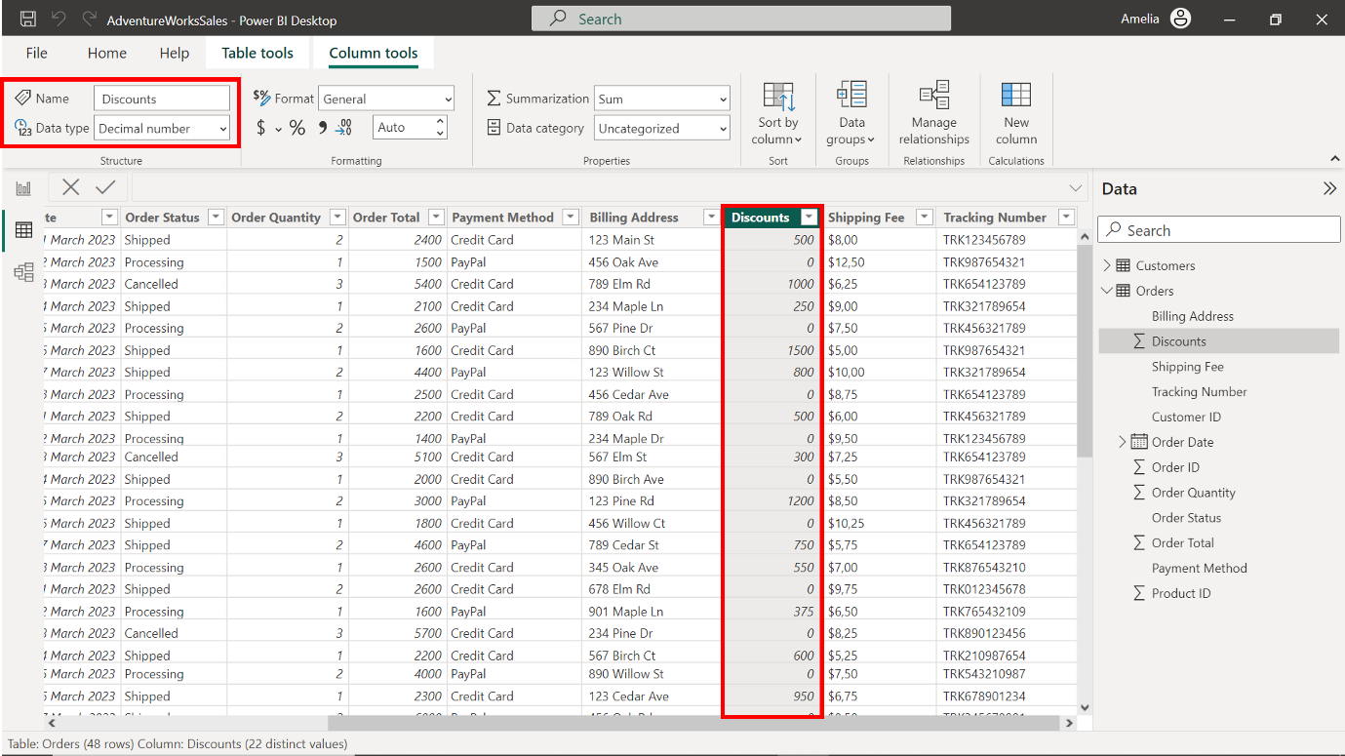

Change the data type of the **Shipping Fee** column to **Decimal Number**.

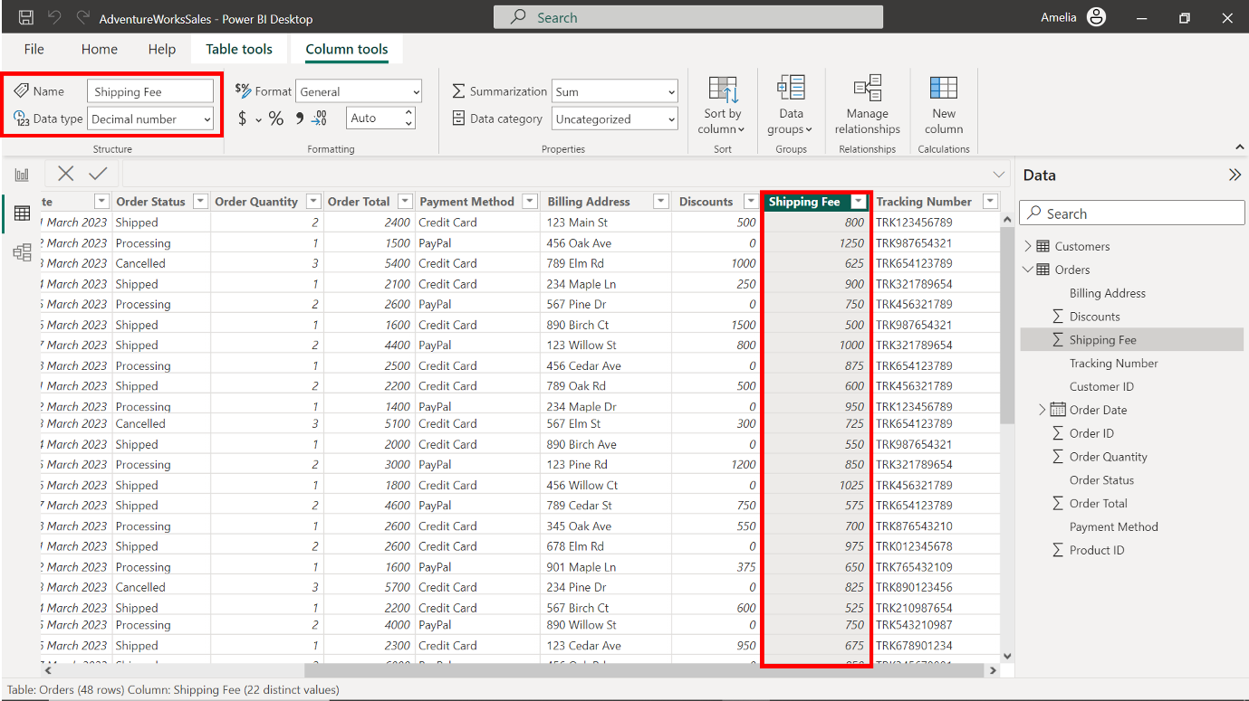

* Change the data type of the **Tracking Number** column to **Text**.

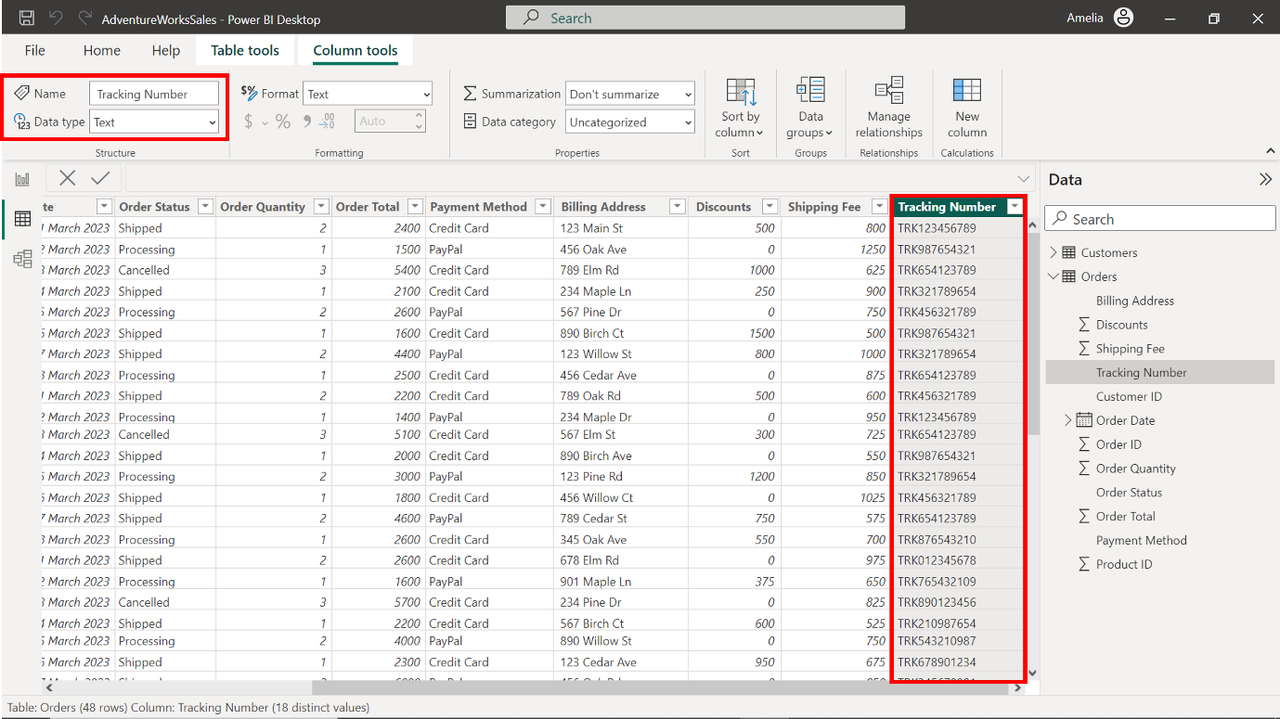

**Step 4: Build and configure the model relationships.**

1. Locate and select the **Model** icon on the left toolbar. This transitions your workspace into the **Model View**, which vividly represents tables and their inter-relationships.

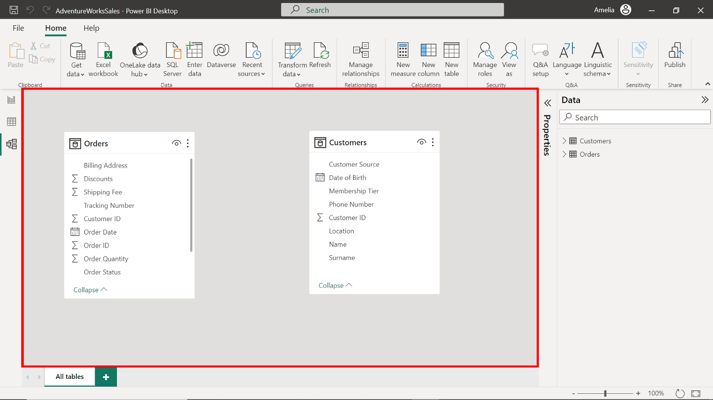

1. In the **Customers** table, the **Customer ID** is a unique identifier for every customer. The **Customer ID** column also exists on the **Orders** table. This indicates which customer placed each order. This commonality between the tables can be used to establish a relationship. Select the **Customer ID** field in the **Customers** table. Hold down the selection and drag a connecting line to the **Customer ID** field in the **Orders** table.

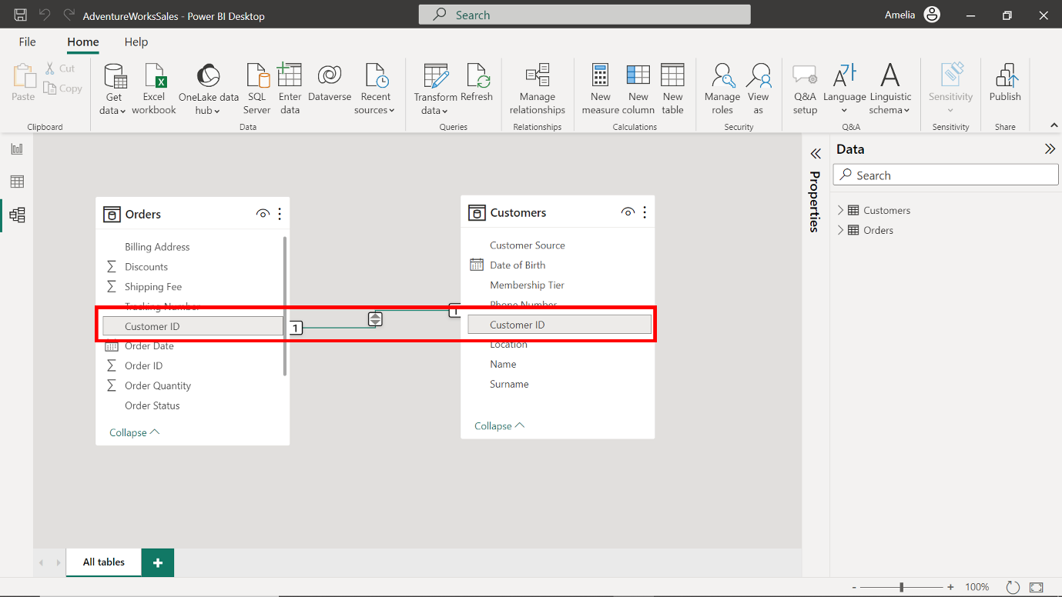

1. Next, let’s define the type of relationship. Double-click on the connecting line you've drawn between the tables to open the **Properties** pane. In the context of Adventure Works, one customer (from the **Customers** table) can have multiple orders (in the **Orders** table). Hence, this is a **One-to-many** relationship.

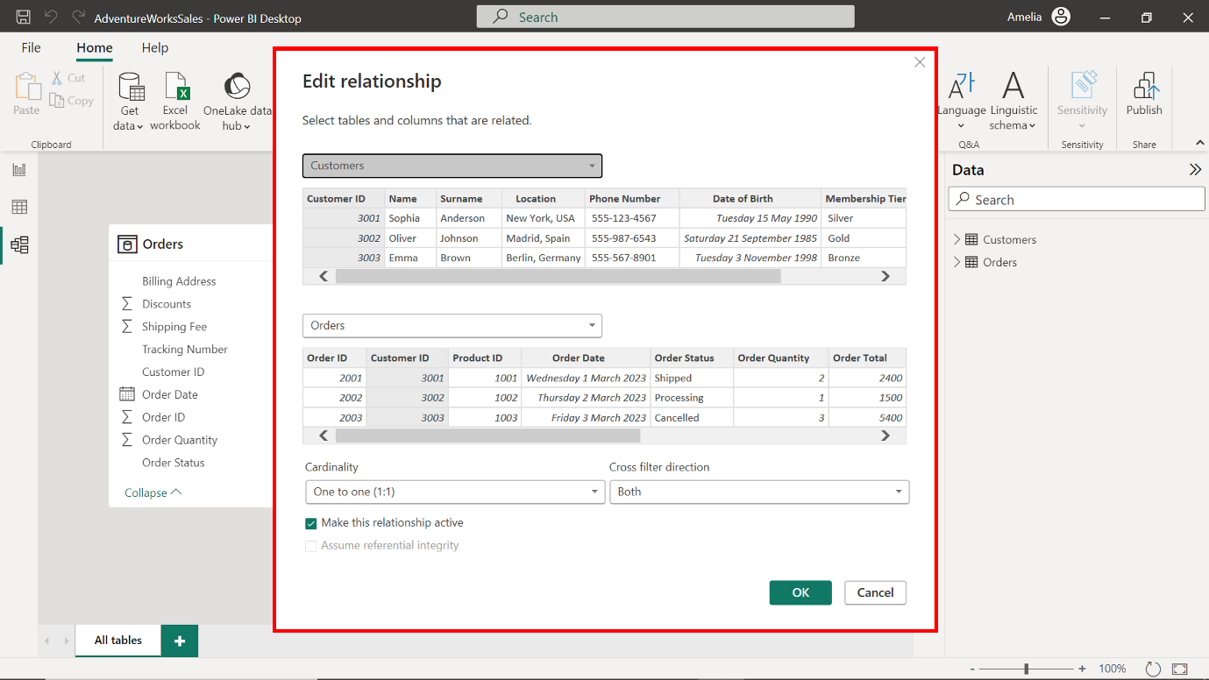

1. For Cardinality, change the selection from its current state to **One-to-many** to improve performance (**One-to-many** relationships are often simpler and faster for Power BI to navigate when loading data and calculating results.)

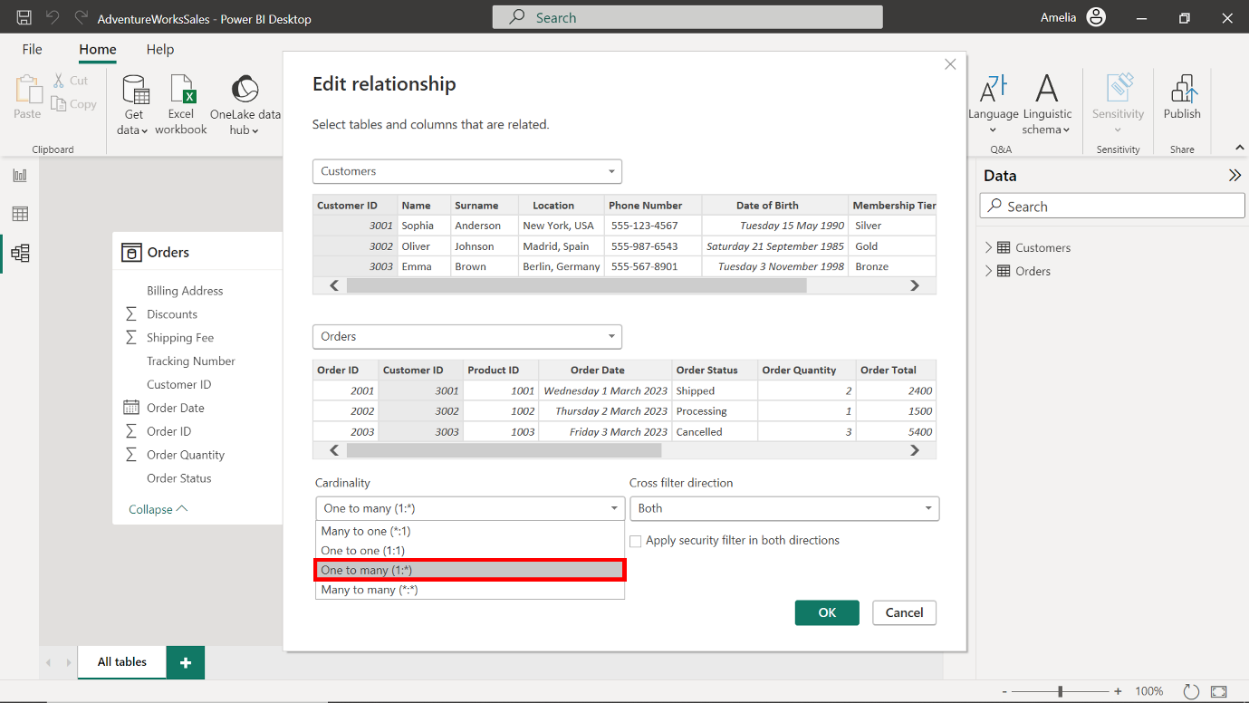

1. To establish a cross-filter direction, choose the **Single** option. By keeping the filter direction singular, you can maintain a simplified data model, ensuring quick and efficient data retrievals.

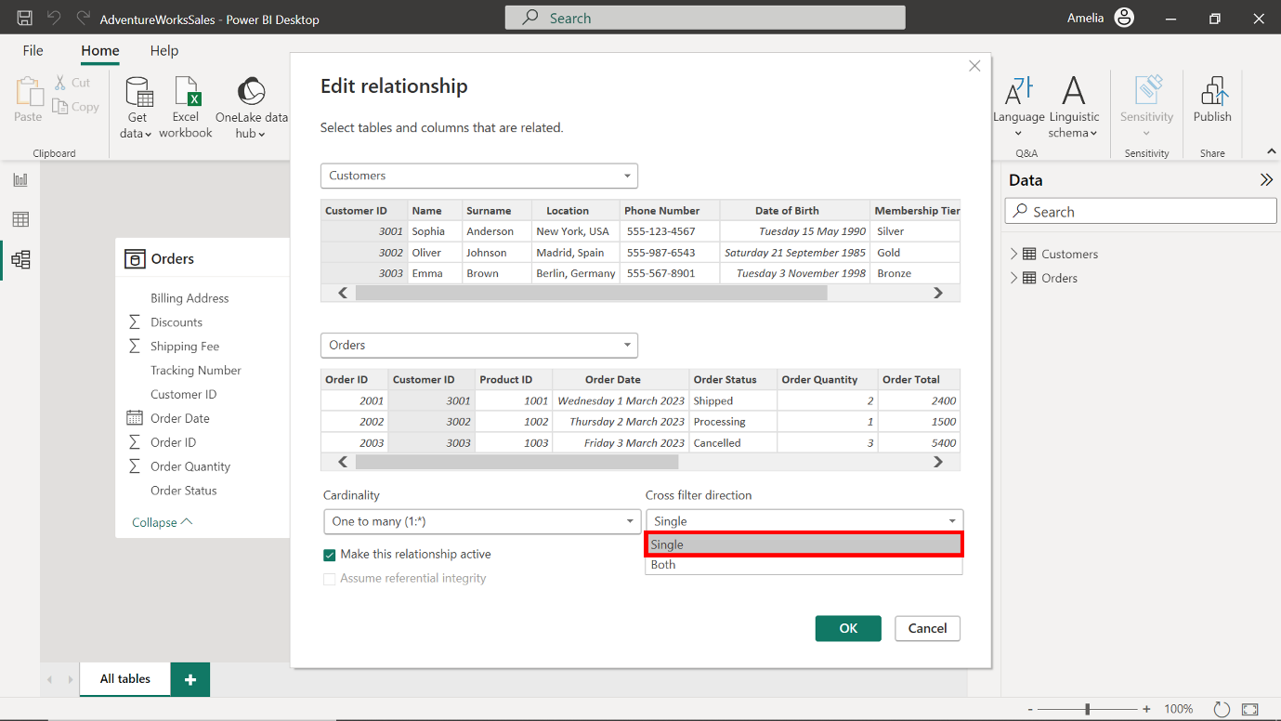

1. To save the changes made to the data model, select the **OK** button at the bottom right corner of the dialog box.

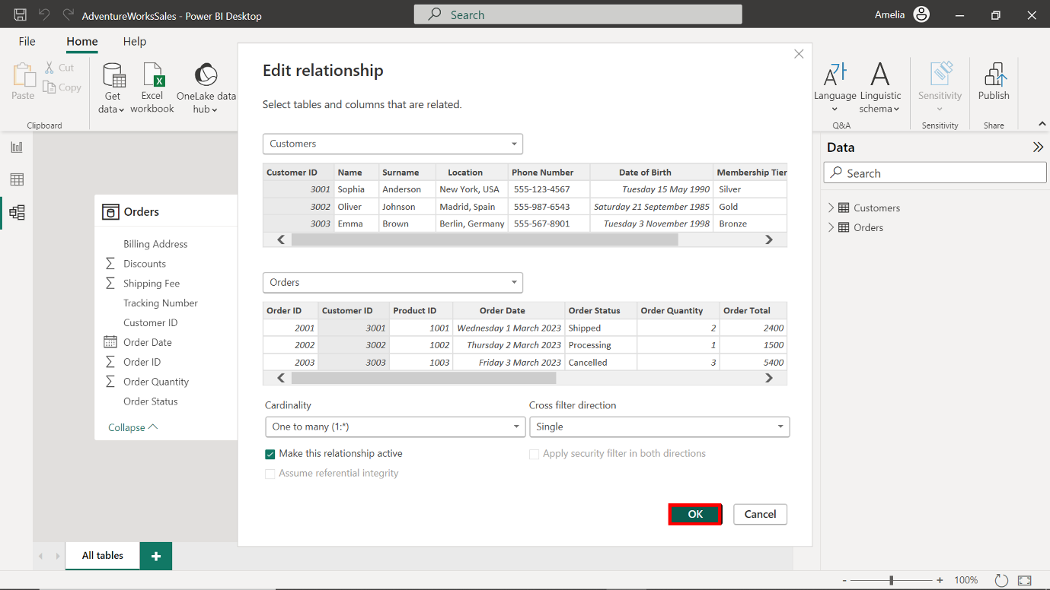

**Step 5: Disable Auto/Date Time**

1. Select the **File** tab in the toolbar. From the dropdown menu, select **Options and settings**, then select **Options**. This option contains several sub-options that allow you to customize and control various aspects of Power BI.

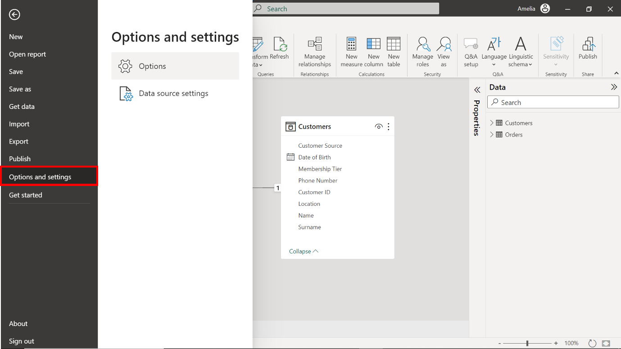

1. An **Options** window appears onscreen. Select **Data Load** under the **Current file** section from the **Options** on the left-hand side of the window.

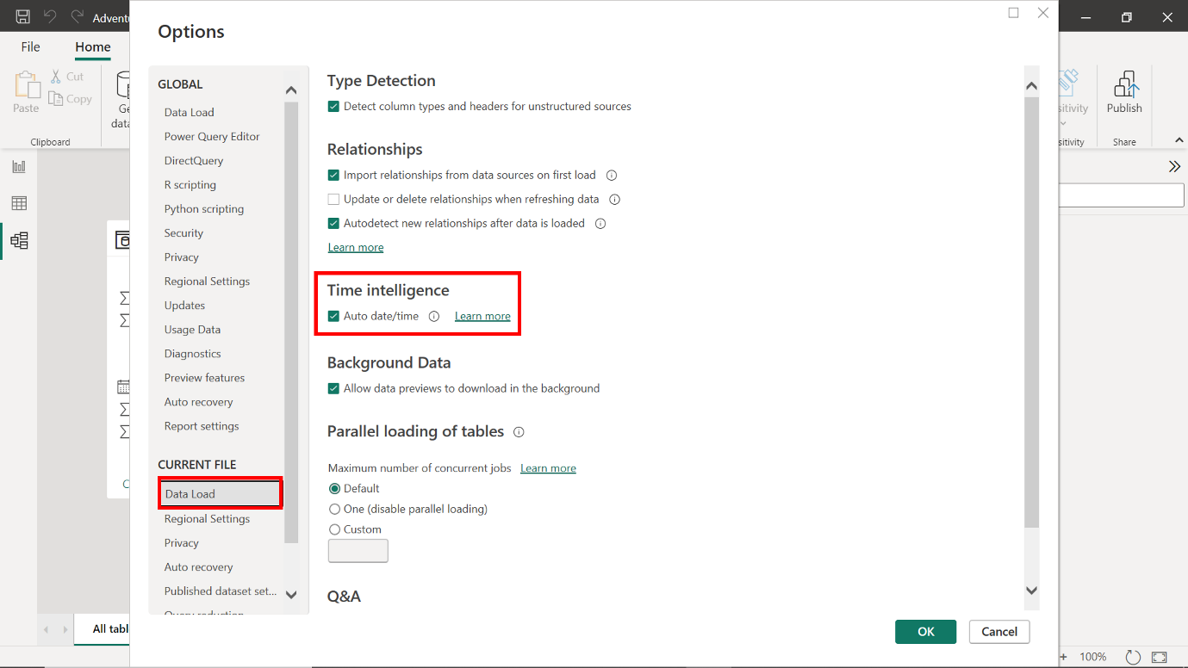

1. In the **Data Load** options is a checkbox labeled **Auto date/time**. This box is checked by default, which means the feature is enabled. Uncheck this box to turn off the current file's **Auto Date/Time feature**.

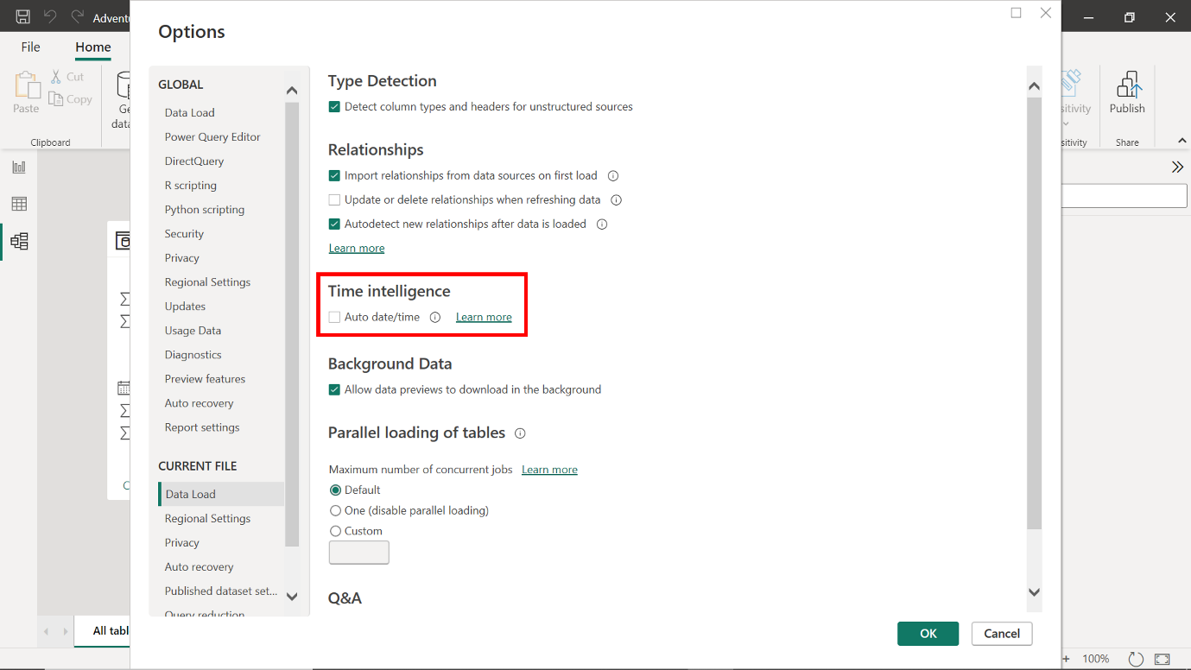

1. Select **OK** to apply the changes. This enables Adventure Works teams to retain greater control over how date information is displayed in their reports.

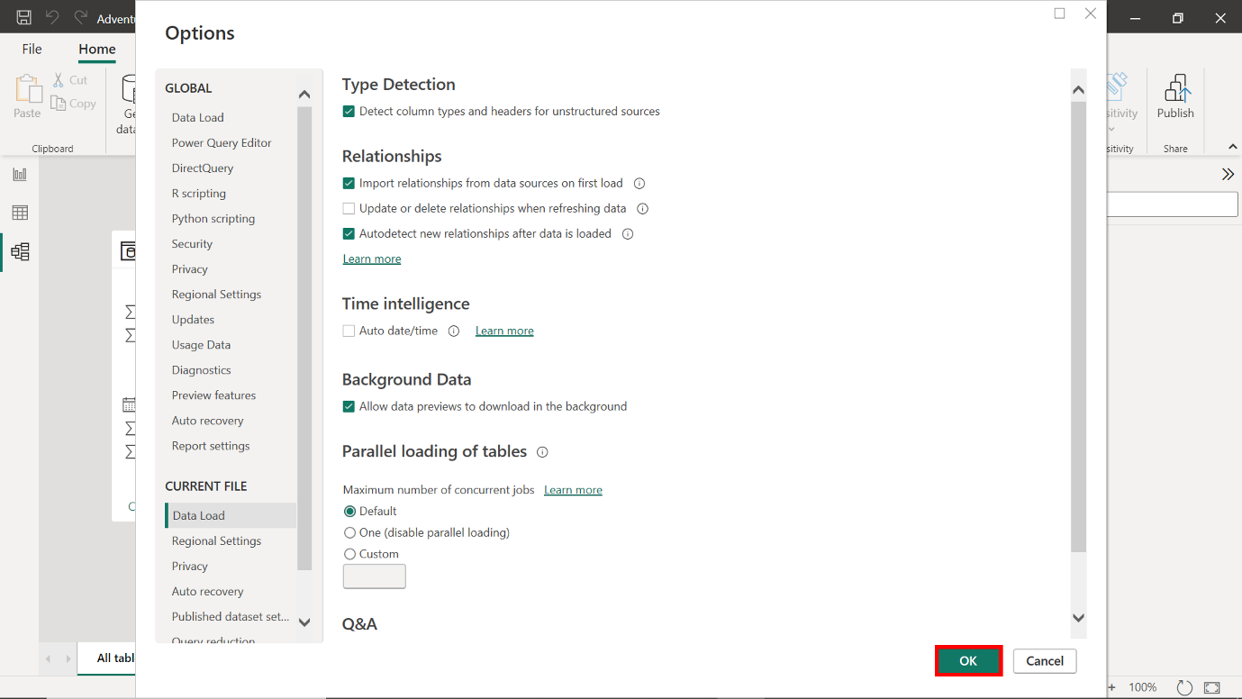

**Conclusion**

By completing these steps, you have successfully built, configured, and optimized a data model for Adventure Works.